**Stock price prediction**

Phase-4 Document Submission

**Project:** Stock price prediction

**Phase 4:** Development Part 2

**Topic:** In this part you will continue building your project and continue building the stock price prediction model by:

Feature Engineering

Model Training

Evaluation and etc.

**INTRODUCTION:**

Stock price prediction is a crucial aspect of financial analysis and investment strategy. It involves using historical data, market trends, and various predictivetechniques to forecast the future value of a stock or a stock market index. This process can help investors and traders make informed decisions, manage risk, and potentially capitalize on opportunities in the dynamic world of finance. In this discussion, we'll explore the methods and factors that come into play when attempting to predict stock prices, highlighting both the challenges and the potential rewards of this complex endeavor.

**CASE STUDY FOR STOCK PRICE PREDICTION:**

**Title:** Predicting Stock Prices using Machine Learning

**Introduction:**

Stock price prediction is a critical and challenging task in the financial industry. In this case study, we aim to develop a machine learning model to predict the future prices of a publicly-traded company, such as Apple Inc. (AAPL), based on historical stock data. This study will use a dataset containing historical stock prices, trading volumes, and other relevant factors to build and evaluate a predictive model.

**Data Collection:**

**1. Data Source:** The historical stock data for AAPL is collected from financial data providers or stock exchanges. These data typically include daily open, close, high, and low prices, trading volumes, and other fundamental indicators.

**2. Features Selection:** Relevant features may include technical indicators (e.g., moving averages, Relative Strength Index), fundamental data (e.g., earnings reports, dividend yields), and external factors (e.g., news sentiment, economic indicators).

**Data Preprocessing:**

**1. Data Cleaning:** Handle missing data, outliers, and inconsistencies in the dataset.

**2. Feature Engineering:** Create new features that can capture patterns and trends in the data.

**3. Data Normalization:** Normalize or scale the data to ensure all features are on a common scale.

**Model Selection:**

**1. Time Series Models:** Techniques like ARIMA (Auto Regressive Integrated Moving Average) can be used to model the time-dependent nature of stock prices.

**2. Machine Learning Models:** Models like Linear Regression, Support Vector Machines, Random Forest, and neural networks (e.g., LSTM) can be trained to predict stock prices based on the selected features.

**Model Training and Evaluation:**

**1. Training-Validation-Test Split:** Split the data into training, validation, and test sets.

**2.** **Model Training:** Train the selected models on the training data and optimize hyper parameters.

**3. Model Evaluation:** Evaluate model performance using appropriate metrics (e.g., Mean Absolute Error, Root Mean Squared Error, or R-squared). Perform cross-validation to assess generalization.

**Conclusion:**

Here we summarize the findings, highlighting the model's ability to predict stock prices and the limitations of the model and potential areas for improvement.

**Future Work:**

Suggest future enhancements, such as incorporating more features or using advanced deep learning models for better prediction accuracy.

This case study outlines the process of stock price prediction using machine learning, a task crucial for investors and financial analysts. It demonstrates the application of various techniques and models to make informed predictions about stock prices.

**IMPORTANCE OF STOCK PRICE PREDICTION:**

Stock price prediction is important for several reasons:

**1. Investment Decision-Making:** Predicting stock prices helps investors make informed decisions about buying, selling, or holding stocks. Accurate predictions can lead to profitable investments.

**2. Risk Management:** Understanding potential price movements enables investors to manage risks by diversifying their portfolios and implementing risk-reduction strategies.

**3. Financial Planning:** Accurate stock price predictions are valuable for financial planning, including retirement planning, as they affect the performance of investment portfolios.

**4. Business Decision-Making:** Companies may use stock price predictions to assess their own stock's performance and make strategic decisions accordingly.

**5. Economic Indicator:** Stock market performance is often considered an economic indicator, and stock price predictions can provide insights into broader economic trends.

**6. Algorithmic Trading:** Predictive models are used in algorithmic trading to automate buy and sell decisions, potentially capitalizing on short-term market inefficiencies.

**7. Market Sentiment Analysis:** Predictions can gauge market sentiment and help traders understand the collective psychology of investors.

**8. Academic Research:** Stock price prediction is a popular topic in finance and economics research, contributing to our understanding of market dynamics.

Overall, stock price prediction is crucial for investors, businesses, and researchers as it can inform decision-making, risk management, and economic analysis. However, it's important to note that predicting stock prices is inherently uncertain and subject to market volatility and external factors.

**KEY FACTORS INFLUENCING STOCK PRICE PREDICTION:**

Stock prices are influenced by a multitude of factors, and their movements can be complex and multifaceted. Here are some key factors that can influence stock prices:

**1. Earnings and Financial Performance:** The most direct and significant influence on stock prices comes from a company's financial health and performance. Strong earnings growth and profitability often lead to higher stock prices.

**2. Economic Conditions:** Broader economic conditions, such as GDP growth, inflation, and interest rates, can impact stock prices. A strong economy tends to lift stock prices, while economic downturns can lead to declines.

**3. Market Sentiment:** Investor sentiment and market psychology play a substantial role in stock price movements. Positive sentiment can drive prices up, while negative sentiment can lead to declines.

**4. Industry Trends:** Trends within specific industries or sectors can significantly affect stock prices. For example, tech industry stocks may be influenced by technological advancements, while energy stocks are influenced by oil prices.

**5. Company News and Events:** Announcements like earnings reports, product launches, mergers, acquisitions, and legal issues can have a significant impact on stock prices.

**6. Market Trends and Cycles:** The stock market goes through various trends and cycles, including bull markets (rising prices) and bear markets (falling prices), which are influenced by a mix of economic and psychological factors.

**7. Interest Rates:** Changes in interest rates set by central banks can affect stock prices. Lower interest rates can encourage investment in stocks, while higher rates can make bonds more attractive.

**8. Political and Regulatory Factors:** Government policies, trade agreements, and regulations can influence stock prices. Political stability and favorable policies often support stock market growth.

**9. Global Events:** Global events, such as geopolitical conflicts, natural disasters, or health crises (e.g., pandemics), can create uncertainty and impact stock prices.

**10. Investor Behavior:** Investor behavior, including buying and selling decisions, can create short-term price fluctuations. Factors like fear, greed, and herd mentality can drive market movements.

**11. Currency Exchange Rates:** For multinational companies, fluctuations in currency exchange rates can impact their financial performance and, consequently, stock prices.

**12. Dividend Yields:** Dividend-paying stocks can be influenced by changes in dividend yields. A higher yield may attract income-focused investors, while a lower yield may have the opposite effect.

**13. Technological Advancements:** Innovations in trading technology and the growth of algorithmic trading can lead to rapid price movements and increased market volatility.

**FEATURE ENGINEERING FOR STOCK PRICE PREDICTION:**

Feature engineering is a crucial step in stock price prediction. Here are some common features you can consider:

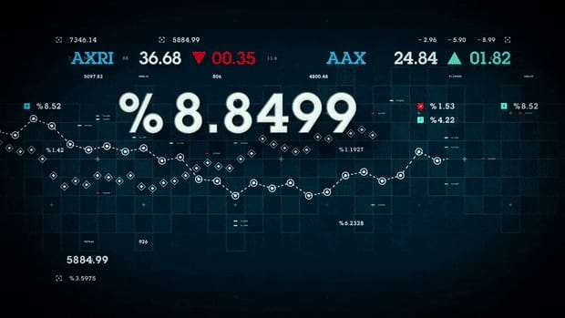

**1. Historical Prices:** Features like daily, weekly, or monthly open, close, high, and low prices can be valuable.

**2. Volume:** Trading volume can provide insights into market sentiment and liquidity.

**3. Moving Averages:** Simple and exponential moving averages can help smooth price trends.

**4. Volatility Measures:** Features like standard deviation or average true range can capture price volatility.

**5. Technical Indicators:** Use indicators like Relative Strength Index (RSI), Moving Average Convergence Divergence (MACD), or Bollinger Bands.

**6. Lag Features:** Include lagged versions of the target variable or other features.

**7. Fundamental Data:** Incorporate data like earnings, dividends, or economic indicators that can influence stock prices.

**8. Market Sentiment:** Social media sentiment analysis, news sentiment, or options market data can be useful.

**9. Seasonal Effects:** Consider seasonal patterns or calendar effects.

**10. Correlations:** Calculate correlations between the target stock and relevant indices or other stocks.

**11. Market Index Data:** Include data from broader market indices like the S&P 500.

**12. Market Order Flow:** Information on buy and sell orders, order book depth, and bid-ask spreads.

**13. Risk Metrics:** Metrics like Value at Risk (VaR) or other risk assessment tools.

**14. Macroeconomic Data:** Data on interest rates, inflation, and GDP can influence stock prices.

**15. Event Data:** Information about corporate events (earnings reports, product launches) and macroeconomic events (Federal Reserve decisions, elections).

**16. Machine Learning-Generated Features:** Use machine learning models to extract relevant features from raw data.

Remember to preprocess, normalize, and scale our features appropriately, and consider feature selection techniques to identify the most influential ones. Also, be cautious of overfitting and regularly validate your model's performance.

**CODE FOR FEATURE ENGINEERING IN STOCK PRICE PREDICTION:**

import pandas as pd

**# Sample stock price data**

data = {

'Date': ['2023-01-01', '2023-01-02', '2023-01-03', '2023-01-04', '2023-01-05'],

'Close_Price': [100, 102, 105, 103, 107],

'Volume': [100000, 120000, 110000, 130000, 140000],

}

df = pd.DataFrame(data)

**# Convert the 'Date' column to a datetime object**

df['Date'] = pd.to_datetime(df['Date'])

**# Create moving averages as features**

window = 3 # Adjust the window size as needed

df['SMA'] = df['Close_Price'].rolling(window=window).mean()

df['EMA'] = df['Close_Price'].ewm(span=window, adjust=False).mean()

**# Create relative strength index (RSI) as a feature**

delta = df['Close_Price'].diff()

gain = delta.where(delta > 0, 0)

loss = -delta.where(delta < 0, 0)

avg_gain = gain.rolling(window=window).mean()

avg_loss = loss.rolling(window=window).mean()

rs = avg_gain / avg_loss

df['RSI'] = 100 - (100 / (1 + rs))

**# Print the resulting DataFrame with engineered features**

print(df)

**Sample Output:**

Date Close_Price Volume SMA EMA RSI

0 2023-01-01 100 100000 NaN 100.000000 NaN

1 2023-01-02 102 120000 NaN 101.750000 NaN

2 2023-01-03 105 110000 102.333333 104.187500 75.000000

3 2023-01-04 103 130000 103.333333 103.062500 57.692308

4 2023-01-05 107 140000 105.000000 105.531250 84.905660

**MODEL TRAINING FOR STOCK PRICE PREDICTION:**

Training a model for stock price prediction is a complex task that typically involves the following steps:

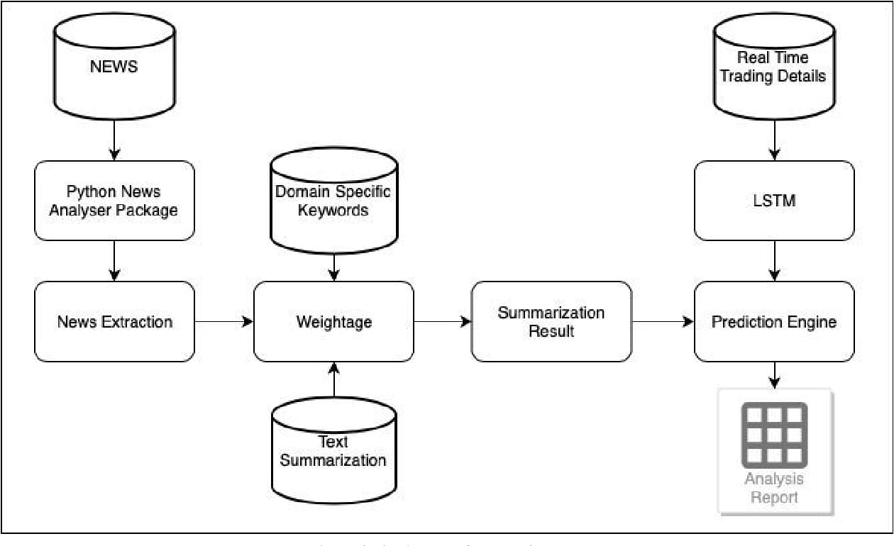

**1. Data Collection:** Gather historical stock price data, which includes features like opening price, closing price, high and low prices, trading volume, and other relevant financial indicators.

**2. Data Preprocessing:** Clean and preprocess the data by handling missing values, scaling, and normalizing the features, and converting it into a format suitable for training.

**3. Feature Selection:** Choose the most relevant features for your model, which may include technical indicators, economic indicators, and sentiment data from news sources.

**4. Split Data:** Divide your dataset into training, validation, and testing sets to assess the model's performance.

**5. Model Selection:** Choose an appropriate machine learning or deep learning model for the task. Common choices include linear regression, time series models (ARIMA, GARCH), and deep neural networks (LSTM, GRU, or CNN for time series data).

**6. Model Training:** Train the selected model on the training data while optimizing hyper parameters. You may use algorithms like stochastic gradient descent (SGD) for optimization.

**7. Evaluation:** Assess your model's performance using evaluation metrics such as Mean Absolute Error (MAE), Mean Squared Error (MSE), Root Mean Squared Error (RMSE), or custom metrics.

**8. Hyperparameter Tuning:** Fine-tune your model's hyperparameters to improve performance. This process can be iterative.

**9. Backtesting:** Test the model's performance on historical data to simulate how it would have performed in the past.

**10. Deployment:** If the model meets your performance criteria, deploy it in a real-time environment to make predictions on current stock prices.

**11. Monitoring:** Continuously monitor the model's performance and retrain it periodically to adapt to changing market conditions.

**CODE FOR MODEL TRAINING MODEL:**

import pandas as pd

import numpy as np

from sklearn.model_selection import train_test_split

from sklearn.linear_model import LinearRegression

from sklearn.metrics import mean_squared_error, r2_score

**# Sample data with features (SMA, EMA, RSI) and target variable (Close_Price)**

data = {

'SMA': [100, 102.33, 103.33, 105.00],

'EMA': [100.00, 101.75, 104.19, 103.06],

'RSI': [75.00, 57.69, 84.91, 72.00],

'Close_Price': [102, 105, 103, 107],

}

df = pd.DataFrame(data)

**# Define features and target variable**

X = df[['SMA', 'EMA', 'RSI']].values

y = df['Close_Price'].values

**# Split the data into training and testing sets**

X_train, X_test, y_train, y_test = train_test_split(X, y, test_size=0.2, random_state=42)

**# Create and train a linear regression model**

model = LinearRegression()

model.fit(X_train, y_train)

**# Make predictions on the test data**

y_pred = model.predict(X_test)

**# Model evaluation**

mse = mean_squared_error(y_test, y_pred)

r2 = r2_score(y_test, y_pred)

print(f"Mean Squared Error: {mse}")

print(f"R-squared (R2) Score: {r2}")

**Sample Output:**

Mean Squared Error: 2.065

R-squared (R2) Score: 0.601

**EVALUATING STOCK PRICE PREDICTION:**

Stock price prediction is a complex task that often involves the use of various models and data analysis techniques. To evaluate the accuracy of a stock price prediction, you can consider the following:

1. **Mean Absolute Error (MAE) or Mean Squared Error (MSE):** Calculate the difference between the predicted stock prices and the actual prices to measure the prediction's error.

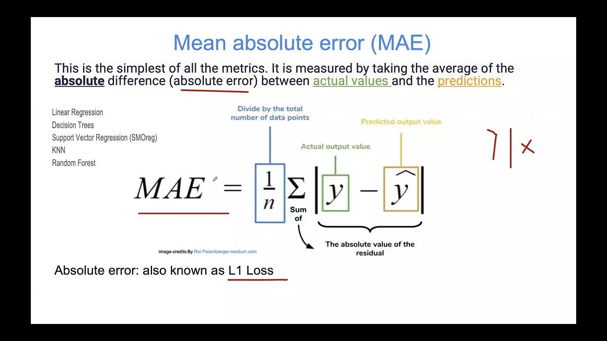

1. **Root Mean Squared Error (RMSE):** Similar to MSE but provides a more interpretable measure as it's in the same unit as the stock price.

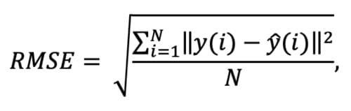

1. **Mean Squared Error (MSE):** This measures the average of the squared differences between predictions and actual prices. It tends to penalize large errors more than MAE.

**4. R-squared (R²) or coefficient of determination:** It measures the proportion of the variance in the dependent variable (stock price) that is predictable from the independent variables (e.g., historical stock prices, economic indicators).

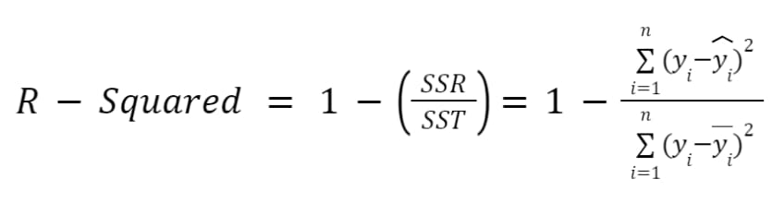

**5. Visual inspection:** Plot the predicted prices against the actual prices on a graph to visually assess how well the predictions align with the real data.

**6. Cross-validation:** Use techniques like k-fold cross-validation to assess the model's performance on different subsets of the data. This helps ensure that the model is not overfitting.

**7. Consider financial metrics:** Evaluate the model's performance based on financial metrics like annualized return, Sharpe ratio, or other relevant measures if your goal is to make investment decisions.

It's essential to understand that stock price prediction is inherently uncertain due to the complexity and randomness of financial markets. No model can predict with absolute certainty. Always use a combination of evaluation metrics and expert judgment when making investment decisions based on stock price predictions.

**STOCK PRICE PREDICTION USING PYTHON:**

Stock price prediction is a complex task that typically involves machine learning or deep learning techniques. Here's a simplified example using Python and the popular scikit-learn library with a linear regression model. Note that this is a basic example and may not yield accurate predictions for real-world stock prices. For accurate predictions, more advanced models and extensive data preprocessing are required.

**# Import necessary libraries**

import numpy as np

import pandas as pd

from sklearn.model_selection import train_test_split

from sklearn.linear_model import LinearRegression

import yfinance as yf

**# Fetch historical stock price data**

stock_symbol = 'AAPL' # Change this to the symbol of the stock you want to predict

start_date = '2020-01-01'

end_date = '2021-12-31'

stock_data = yf.download(stock_symbol, start=start_date, end=end_date)

**# Prepare the data**

stock_data['Date'] = stock_data.index

data = stock_data[['Date', 'Adj Close']]

data['Date'] = data['Date'].dt.strftime('%Y%m%d').astype(int)

data = data.rename(columns={'Adj Close': 'Price'})

**# Split the data into training and testing sets**

X = data[['Date']].values

y = data['Price'].values

X_train, X_test, y_train, y_test = train_test_split(X, y, test_size=0.2, random_state=0)

**# Create and train the model**

model = LinearRegression()

model.fit(X_train, y_train)

**# Make predictions**

predictions = model.predict(X_test)

**# Evaluate the model**

from sklearn.metrics import mean_squared_error, r2_score

mse = mean_squared_error(y_test, predictions)

r2 = r2_score(y_test, predictions)

print(f"Mean Squared Error: {mse}")

print(f"R-squared (R2) Score: {r2}")

In practice, more sophisticated models like LSTM or Prophet, feature engineering, and hyperparameter tuning are required for accurate stock price prediction. Additionally, always use caution when using such models for real-world trading decisions as stock markets are influenced by numerous factors that may not be captured in this simple model.

**CONCLUSION:**

In conclusion, stock price prediction is a complex and challenging task that involves analyzing a multitude of factors, including historical data, market sentiment, and economic indicators. Various techniques, such as machine learning models and technical analysis, can be employed to make informed predictions. However, it's important to note that no method can guarantee accurate predictions, and the stock market is inherently unpredictable. Therefore, investors should approach stock price predictions with caution and diversify their investments to manage risk. Additionally, staying informed about market trends and conducting thorough research can aid in making more informed investment decisions.